SHO MADJOZI RIDERS- April 2022

TECHNICAL RIDER
● 2 x Pioneer CDJ2000s
● 1 x Pioneer DJM900nxs2 or comparable model Pioneer mixer
● 1 x Cordless handheld RF microphone for the DJ, tuned to be free of interfering radio frequencies
● 1 x Cordless handheld RF microphone for Sho Madjozi tuned to be free of interfering radio frequencies
● 1 x Cordless handheld RF microphone for Sho Madjozi Back Up tuned to be free of interfering radio frequencies
● 2 x Monitors for DJ with Sho Madjozi mic feed and booth control of DJ mixer MUST BE IN EAR MONITORS FOR STADIUM EVENTS
● 4 x On stage wedge monitors for Sho Madjozi downstage
TOURING PARTY = 5pax total
Lead Vocal Sho Madjozi - Maya Wegerif
Tour Manager- Bongani Caluza
DJ- Thabo Moagi
Dancers - Angel Maputla & Ratanang Motsathebe
TECHNICAL SPECIFICATIONS
Artist is not responsible or liable for any failure of or damage to the equipment for whatever the reason. Artist further reserves the right, without liability, to refuse the use of any equipment that they feel is unfit, unsafe, or fails to meet with the agreed specifications for the engagement.
The sound system shall be set up and tested to be in complete working order before the arrival of the Artist. This includes 3 channels of clear RF microphone signals and stage monitors tuned to remove feedback. The system must be capable of evenly covering the entire listening area and must be able to reach loud levels (120db) without audible distortion (not that we want to get that loud but we want to ensure headroom in the system and by doing so protect your equipment). All speaker enclosures must be of a reputable make. System shall include appropriate amplification, microphones, cables, all necessary rigging hardware, etc. Number of speakers will depend on the type of speaker and size of the venue. Artist and their touring audio crew must have full and unrestricted access to all system processing, including inside the amp racks and processing.

SOUND CHECK
Sho Madjozi requires a sound check and time for spacing the stage for dancing. Typically, load-in & sound check last about 1 hour if the DJ equipment is already set up and wired to the PA.
CHANGEOVER
Sho Madjozi will require a minimum of 30 minutes for a proper changeover and line check at festivals. Vocal microphones should be tuned for clear RF and no feedback in stage wedges before Artist takes the stage for changeover.
MIXING CONSOLES
FOH: Avid D-Show or SC48 (2nd choice: Midas Pro2)
Please insert a Graphic EQ on main output.
Please insert a compressor on all vocal microphones.
A separate audio send to the subwoofers is ideal.
RECORDING
No part or portion of Artist’s performance shall be recorded in audio, video, or reproduced without prior and separate agreements from Artist.

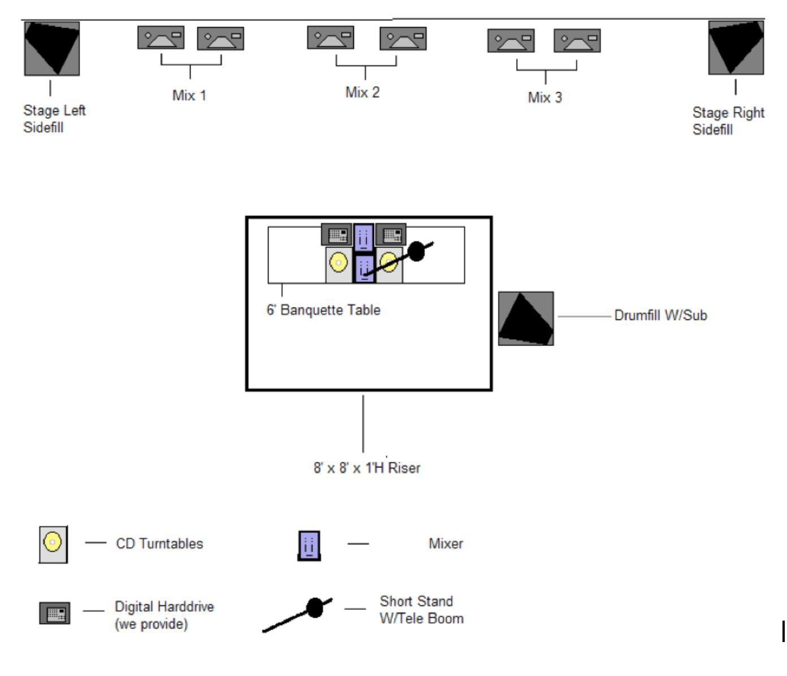

HOSPITALITY RIDER
HOTELS
For all fly dates Sho Madjozi requires (4) hotel rooms. Three with king size beds and one with double occupancy of two queen size beds. Hotel must be a minimum of 4 Stars.
Rooming list;
King Room #1 - Maya Wegerif
King Room #2 - Matthew Duane
King Room #3 - Thabo Moagi
Queen Room #4 - Angel Maputla & Ratanang Motsathebe

TRAVEL
Unless specified otherwise, we insist that everyone travel together. Please be aware that people might be originating from different locations. It is the purchaser's responsibility to provide travel to and from the city of performance in addition to ground transportation on related matters.

Non-stop air travel is required for any destination with a distance of 200 miles from the artist's current location. If non-stop flights are not available through any of the major airlines to the performance destination, then reasonable connections and layovers would be appreciated.

One (1) Business Class airline tickets is required for flights over five (5) hours for Sho Madjozi Four (4) Economy / coach airline tickets are acceptable for the remainder of the traveling party.

One (1) multi-passenger vehicle (i.e. Sport Utility Vehicle) operated by professional, licensed, bonded and insured transportation service for the sole use of the traveling party for the entire day, will be needed for pick- up & delivery to and from the airport, hotel, and venue for sound check and performance. A cargo van will be needed for the transportation of luggage and instruments belonging to the traveling party. Parking must be secured within ten (10) feet of the hotel front door and the venues stage door with a clear and unobstructed path to and from. Chauffeurs/Drivers are to be fully knowledgeable of the cities’ statutes, laws, regulations and ordinances of the applicable states, territories, and counties.

RUNNER
Sho Madjozi requires a runner be made available for the entire evening. Runner must have a reliable vehicle capable of carrying multiple crew, gear, groceries, etc. Runner must remain sober for the duration of the call. For Festivals and fly dates this includes airport pick up and transportation between festival site and hotel.
SECURITY
Purchaser shall guarantee proper security at all times to ensure the safety of Artist, auxiliary personnel, instruments, equipment, costumes and personal property during and after the engagement. Particular security must be provided in the areas of the stage, dressing rooms, and all exits and entrances to the venue and mixing consoles. Security protection is to commence upon arrival of Artist and personnel at the venue until all equipment is repacked into transportation and Artist and personnel have left the premises.

DRESSING ROOMS

Purchaser will provide one (1) dressing room for the sole purpose of the artists/management and a separate room for the travel party. Purchaser guarantees that each room will:
- Be near sanitary toilet facilities with running water, a supply of hand soap, towels and mirrors.
- Contain at least six (5) towels for the stage performance.
- Provide comfortable cushioned seating for at least 5.
- Contain all utensils, (cups, plates and napkins) applicable condiments, food and drink on a banquet type table with a clean tablecloth.
- Have full length mirrors, power outlets and be properly warmed or cooled as necessary.
- Be capable of being locked and the night security person shall have the key.

Each of the dressing rooms should be set up with the following:

- One (1) Tray of Turkey Sandwiches
- 1 x Fresh Fruit platter
- Twelve (12) Kit Kat Milk Chocolate Bars
- Ten (10) 1.69oz Bags of M&M’s
- One (1) Large Bottle of Aloe Juice
- One (1) Bottle of Hennessy
- Five (5) Cans of Red Bull
- One (1) Large Bottle of Martinelli's Regular Apple Juice
- Six (6) Large Bottles of SmartWater (Please put two (2) on ice) NO EXCEPTIONS
- One (1) bag lightly salted Kettle Chips
- Two (2) Black Sharpie Markers
- One (1) case of bottled water

Depending upon the nature of the engagement and performance times, hot meals may be required, in that case, a menu selection is to be placed in each room.
In the event the venue has no food facilities, a dinner buyout will be considered (please confirm with management)

